BATCH MEMBER

INTRODUCTION:

* "In the world of finance, accurately predicting stock prices is crucial for investors and traders. With the advent of machine learning, we have a powerful tool that can enhance our ability to make more accurate predictions.
* Traditional methods of stock analysis have their value but often fall short in capturing the complexity of stock market dynamics. Machine learning, on the other hand, can process vast amounts of data and uncover patterns that human analysts may miss.
* In this exploration, we'll dive into the world of predicting stock prices using machine learning. We'll see how this technology uses algorithms and data to create models that consider various factors like market sentiment, financial indicators, and economic events.
* This transformation in financial analysis benefits not only investors but also financial institutions and policymakers. Accurate stock price predictions can inform investment strategies and economic decisions, making the financial market more efficient and equitable.

Dataset link:

Here's a list of tools and software commonly used in the process:

1. Programming Language:

- Python: Python is the most popular language for stock price prediction due to its extensive libraries and frameworks. Libraries like NumPy, pandas, and scikit-learn are essential.

2. Integrated Development Environment (IDE):

- Jupyter Notebook: Jupyter Notebook is a versatile and widely used environment for coding and running machine learning experiments.

- Google Colab: Google Colab provides a cloud-based Jupyter Notebook environment, which can be handy for collaborative work.

- PyCharm: Traditional IDEs like PyCharm are also commonly used for developing and testing code.

3. Machine Learning Libraries:

- scikit-learn: scikit-learn is a powerful library for building and evaluating machine learning models, making it suitable for stock price prediction.

- TensorFlow or PyTorch: If deep learning is required in your stock prediction model, TensorFlow and PyTorch are popular choices.

- XGBoost, LightGBM, or CatBoost: These libraries are useful for implementing gradient boosting models, which can be effective for stock price prediction.

4. Data Visualization Tools:

- Matplotlib, Seaborn, or Plotly: These visualization libraries are crucial for exploring and visualizing stock market data.

5. Data Preprocessing Tools:

- pandas: pandas is invaluable for data cleaning, manipulation, and preprocessing, which is essential when working with stock data.

6. Data Collection and Storage:

- Web Scraping Tools: Depending on your data source, you might need web scraping tools such as BeautifulSoup or Scrapy to gather stock data from websites.

- Databases: Databases like SQLite or PostgreSQL can be used for storing and managing historical stock data.

7. Version Control:

- Git: Git is an important version control system that helps track changes in your code and facilitates collaboration with team members.

8. Notebooks and Documentation:

- Jupyter Notebooks: Jupyter Notebooks can be used for documenting your work and creating clear, well-structured documentation for your stock prediction model.

- Markdown: Markdown is useful for creating README files and other documentation.

9. Hyperparameter Tuning:

- GridSearchCV or RandomizedSearchCV (from scikit-learn): These tools help optimize the hyperparameters of your machine learning models for better performance in stock price prediction.

10. Web Development Tools (for Deployment):

- Flask or Django: If you plan to deploy your stock prediction model as a web application, knowledge of web development tools like Flask or Django for backend development can be useful.

- HTML, CSS, and JavaScript: These front-end web development technologies can be handy for creating user interfaces for your stock prediction application.

11. Cloud Services (for Scalability):

- AWS, Google Cloud, or Azure: Cloud platforms like AWS, Google Cloud, or Azure can provide scalable computing and storage resources if you are working on large-scale stock prediction applications and need additional computing power and storage capacity.

1.DESIGN THINKING AND PRESENT IN FORM OF DOCUMENT

Design Thinking:

1. Empathize:

* Understand the needs and challenges of our target users, including investors, traders, and financial analysts.
* Gather historical stock price data and related financial information.
* Conduct interviews, surveys, or focus groups to gain insights into user requirements and pain points.

2. Define:

* Clearly define the scope of the problem, specifying the prediction horizon (short-term, long-term).
* Identify key performance metrics for assessing prediction accuracy (e.g., Mean Absolute Error, Root Mean Square Error).
* Establish the target audience and their specific requirements.

3. Ideate:

* Brainstorm potential data sources, such as historical stock prices, company financial reports, news sentiment, and economic indicators.
* Explore a variety of machine learning and statistical models suitable for time series forecasting, such as ARIMA, LSTM, or Prophet.
* Consider feature engineering techniques to extract relevant information from the data.

4. Prototype:

* Develop a prototype or proof-of-concept model for stock price prediction.
* Utilize a subset of historical data to train and validate the model.
* Create a user-friendly interface for inputting stock symbols, date ranges, and desired prediction horizons.

5. Test:

* Evaluate the prototype's accuracy and performance using historical data.
* Gather feedback from potential users to understand the model's strengths and weaknesses.
* Make necessary adjustments to improve prediction quality.

6. Implement:

* Build a production-ready version of the stock price prediction system.
* Incorporate real-time data updates and ensure scalability.
* Deploy the system on a reliable platform accessible to users.

7. Iterate:

* Continuously monitor the model's performance and update it as needed.
* Gather user feedback and make iterative improvements to the user interface and prediction capabilities.
* Stay informed about the latest research and technologies in stock price prediction.

2.DESIGN INTO INNOVATION

INNOVATION:

* News Sentiment Analysis: Incorporate sentiment analysis of news articles and social media posts to gauge public sentiment and its impact on stock prices.
* Natural Language Processing (NLP): Develop advanced NLP models to extract insights from financial news, earnings reports, and other textual data sources.
* Alternative Data Sources: Explore unconventional data sources such as satellite imagery, consumer foot traffic, or social media trends to gain unique insights into market movements.
* Social Network Analysis: Analyze the social networks of influential investors and traders to identify trends and predict market sentiment.
* Quantum Computing: Investigate the potential of quantum computing for more complex and faster data analysis, which can lead to more accurate predictions.
* Blockchain Technology: Utilize blockchain to enhance transparency in stock market data and transaction records, reducing fraud and manipulation.
* Intermarket Analysis: Incorporate data and insights from related markets, such as commodities, currencies, and bond markets, to provide a holistic view of market dynamics.

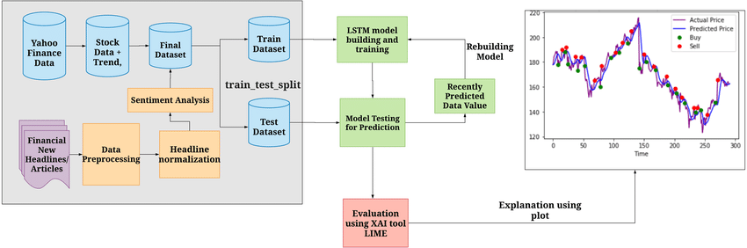

STEPS TO INVOLVE :

1. Data Collection: Gather historical stock market data, including price, volume, and other relevant indicators.

2. Data Preprocessing: Clean and preprocess the stock market data to handle missing values, outliers, and ensure data consistency.

3. Feature Engineering: Create meaningful features and indicators from the stock market data, such as moving averages, relative strength index (RSI), and trading volume.

4. Data Splitting: Divide the dataset into training and testing sets to facilitate model development and evaluation.

5. Model Selection: Choose an appropriate prediction model for stock market analysis, such as time series forecasting, machine learning, or deep learning models.

6. Model Training: Train the selected model using the training dataset to capture historical patterns and relationships.

7. Model Evaluation: Assess the model's performance on the test dataset using metrics like accuracy, precision, recall, and F1-score.

8. Hyperparameter Tuning: Optimize the model's hyperparameters, such as learning rate, batch size, and hidden layers, to improve its predictive accuracy.

9. Final Model Selection: Select the best-performing model based on evaluation results and hyperparameter tuning.

10. Prediction: Utilize the final model to make predictions for stock prices or market trends, providing insights for investors and traders.

3.BUILD LOADING AND PREPROCESSING THE DATASET:

PREPROCESSING THE DATASET:

* Load data in pandas
* Drop columns that aren’t useful
* Drop rows with missing values
* Create dummy variables
* Take care of missing data
* Convert the data frame to numpy
* Divide the data set into training data and test data.

Necessary step to follow:

1.Import Libraries:

Start by importing the necessary libraries

2.Load the Dataset:

Load your dataset into a Pandas DataFrame. You can typically find house price datasets in CSV format, but you can adapt this code to other formats as needed.

3.Exploratory Data Analysis (EDA):

Perform EDA to understand your data better. This includes checking for missing values, exploring the data's statistics, and visualizing it to identify patterns.

4.Feature Engineering:

Depending on your dataset, you may need to create new features or transform existing ones. This can involve one-hot encoding categorical variables, handling date/time data, or scaling numerical features.

5. Split the Data:

Split your dataset into training and testing sets. This helps you evaluate your model's performance later.

6.Feature Scaling:

Apply feature scaling to normalize your data, ensuring that all features have similar scales. Standardization (scaling to mean=0 and std=1) is a common choice

Data preprocessing code in python :

import pandas as pd

import matplotlib.pyplot as plt

from sklearn.cluster import KMeans

from sklearn.preprocessing import StandardScaler

# Load the stock price dataset

data = pd.read_csv('\Python312\DATASETS\MSFT.csv')

# Display the first few rows of the dataset to understand its structure

print(data.head())

# Select relevant features for clustering (e.g., 'Open' and 'Close' prices)

X = data[['Open', 'Close']]

# Standardize the features

scaler = StandardScaler()

X_scaled = scaler.fit_transform(X)

# Determine the optimal number of clusters using the Elbow Method

wcss = [] # Within-Cluster Sum of Squares

for i in range(1, 11):

kmeans = KMeans(n_clusters=i, init='k-means++', max_iter=300, n_init=10, random_state=0)

kmeans.fit(X_scaled)

wcss.append(kmeans.inertia_)

# Plot the Elbow Method to find the optimal number of clusters

plt.plot(range(1, 11), wcss)

plt.title('Elbow Method')

plt.xlabel('Number of clusters')

plt.ylabel('WCSS')

plt.show()

# Based on the Elbow Method, choose an appropriate number of clusters (e.g., 3)

num_clusters = 3

# Apply K-Means clustering with the selected number of clusters

kmeans = KMeans(n_clusters=num_clusters, init='k-means++', max_iter=300, n_init=10, random_state=0)

y_kmeans = kmeans.fit_predict(X_scaled)

# Add the cluster labels to the dataset

data['Cluster'] = y_kmeans

# Visualize the clusters

for cluster_num in range(num_clusters):

plt.scatter(X_scaled[y_kmeans == cluster_num, 0], X_scaled[y_kmeans == cluster_num, 1], s=100, label=f'Cluster {cluster_num + 1}')

plt.scatter(kmeans.cluster_centers_[:, 0], kmeans.cluster_centers_[:, 1], s=300, c='yellow', label='Centroids')

plt.title('Stock Price Clustering')

plt.xlabel('Open Price')

plt.ylabel('Close Price')

plt.legend()

plt.show()

# Explore and analyze each cluster to understand stock price patterns

for cluster_num in range(num_clusters):

cluster_data = data[data['Cluster'] == cluster_num]

print(f'Cluster {cluster_num} Statistics:')

print(cluster_data.describe())

# You can save or export the clustered dataset for further analysis or trading strategies

data.to_csv('stock_price_data_clustered.csv', index=False)

output:

GIVEN DATASET

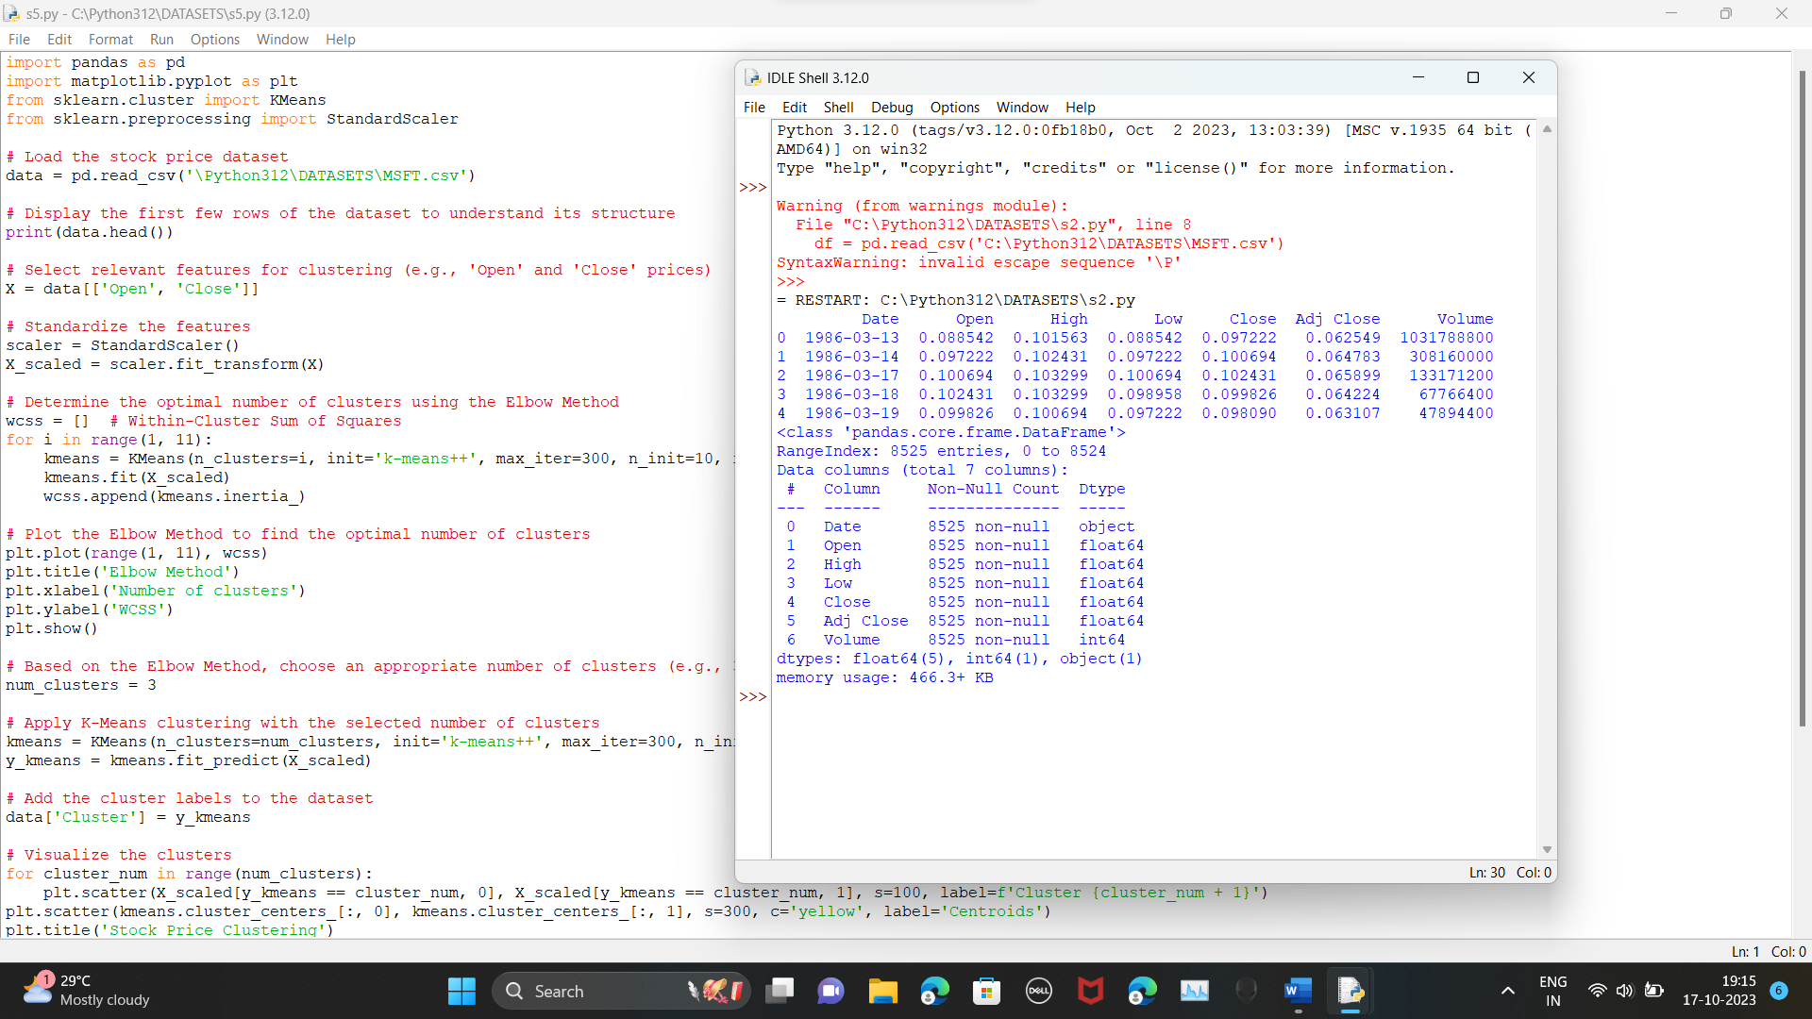

CLUSTER OF DATASET

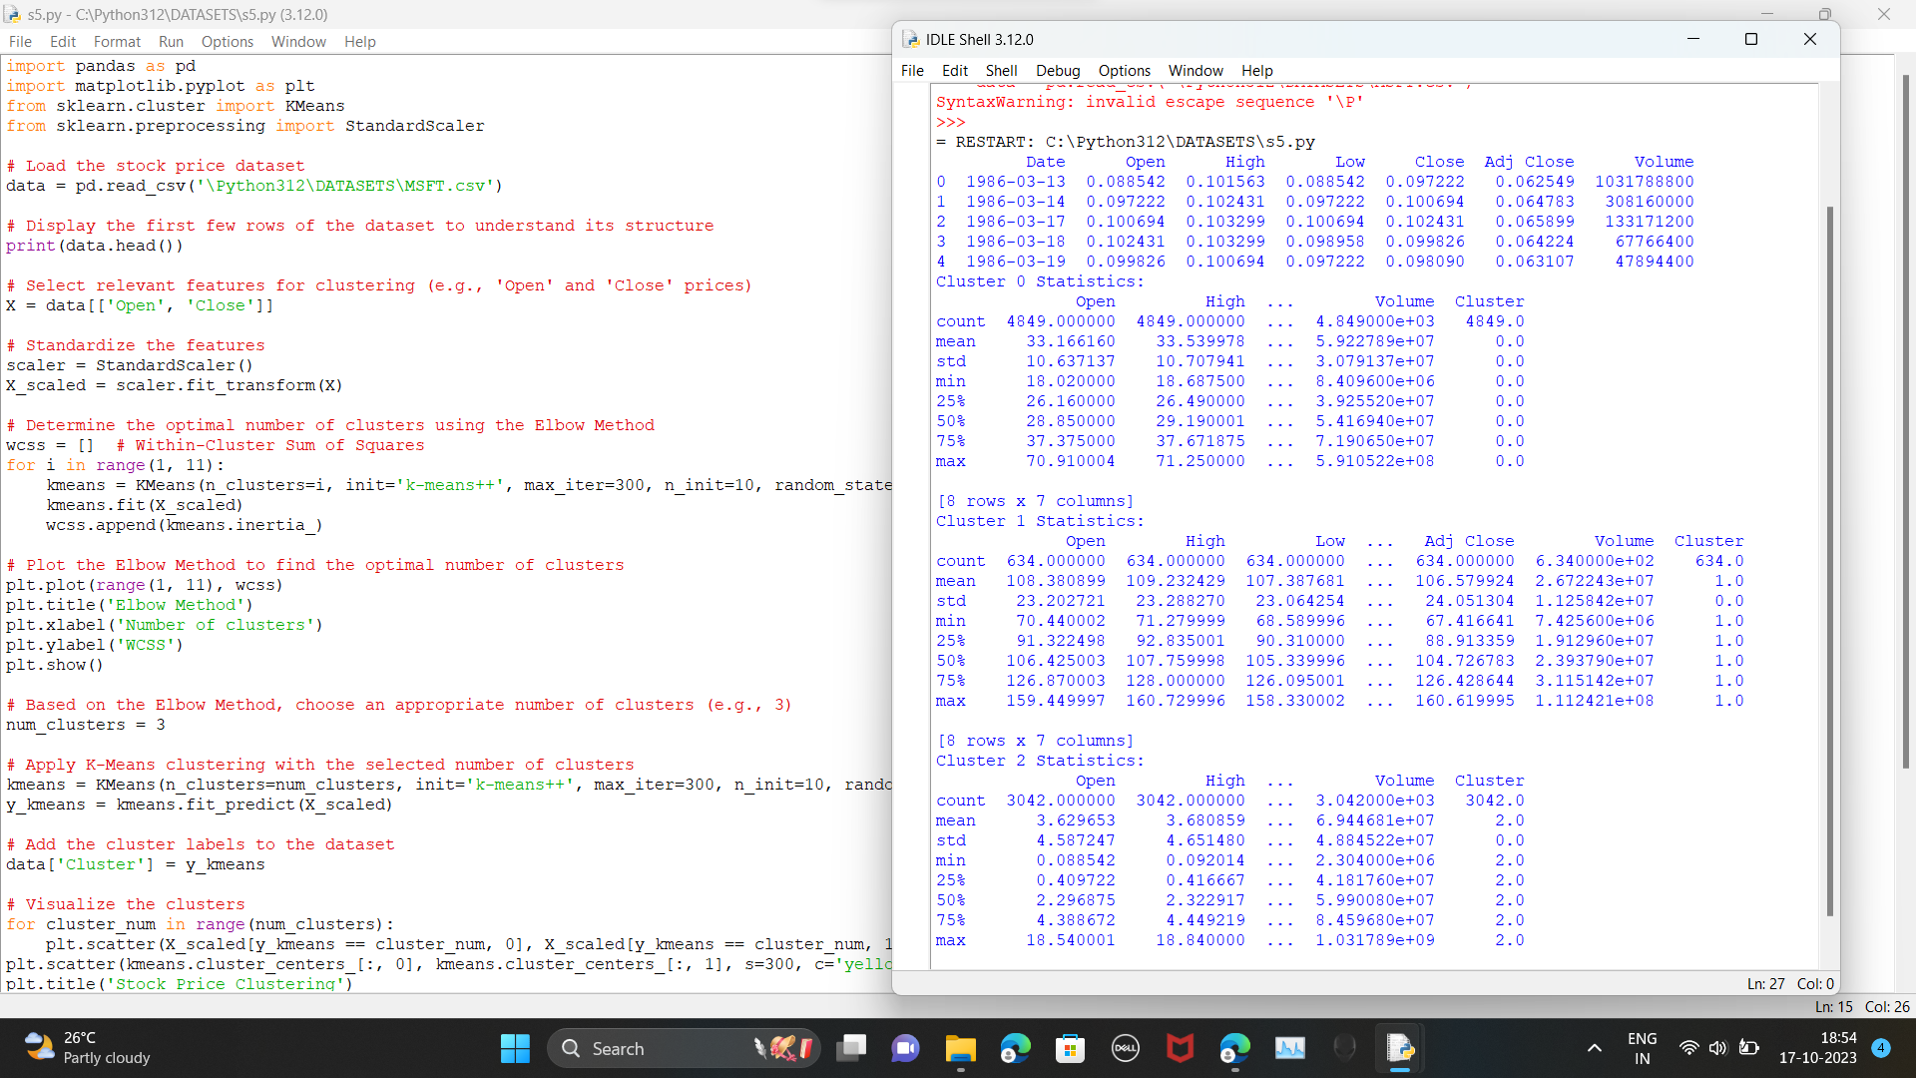

STOCK PRICE PREDICTION

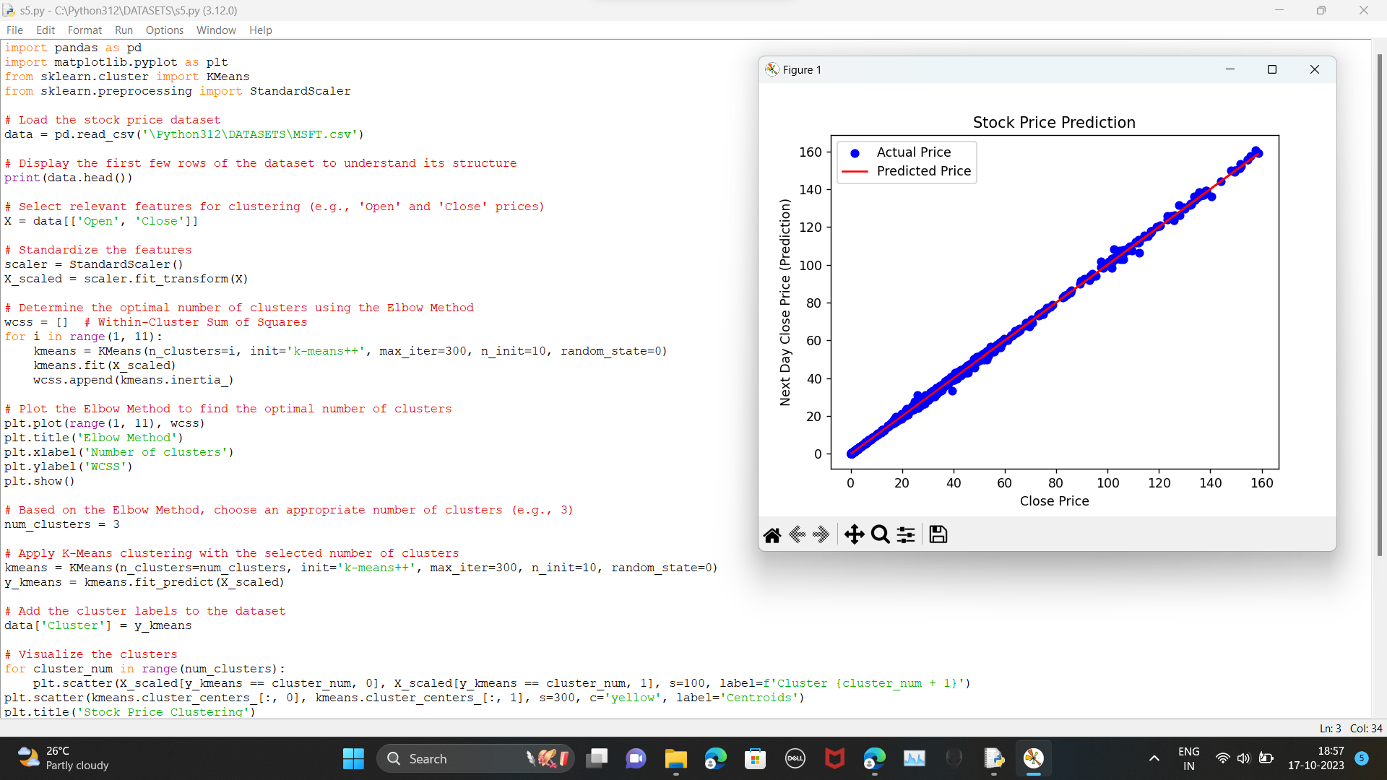

STOCK PRICE CLUSTERING 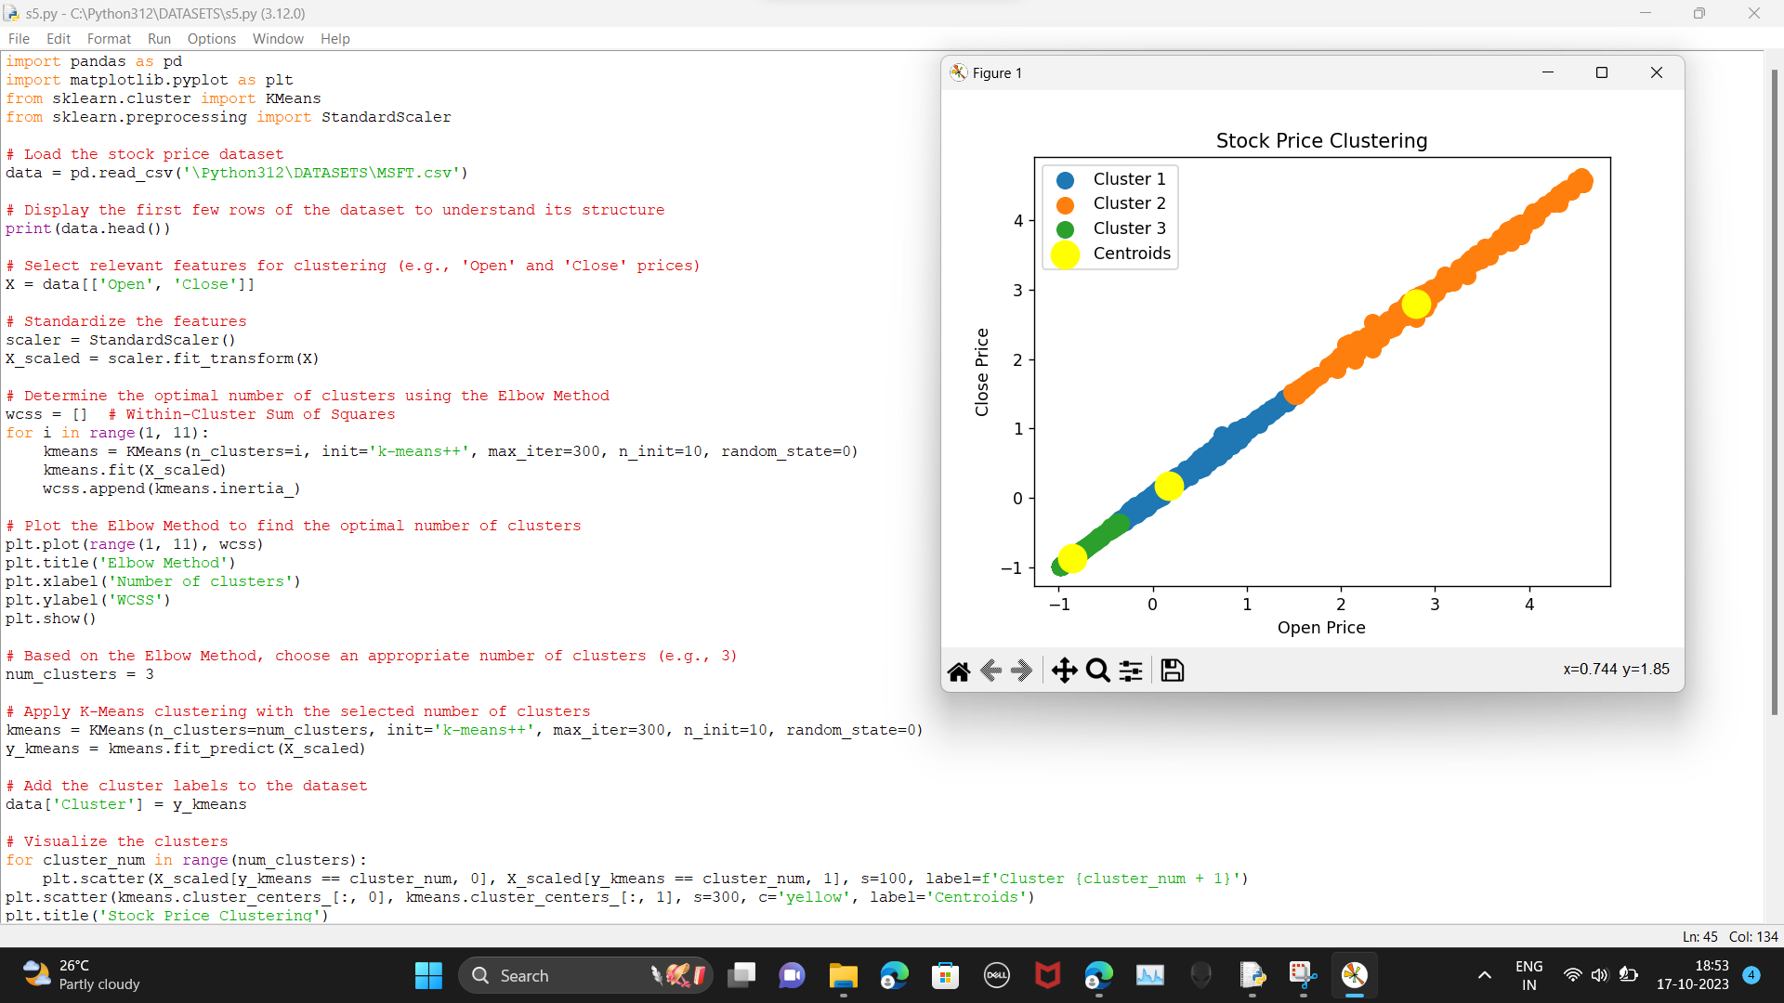

ELBOW METHOD

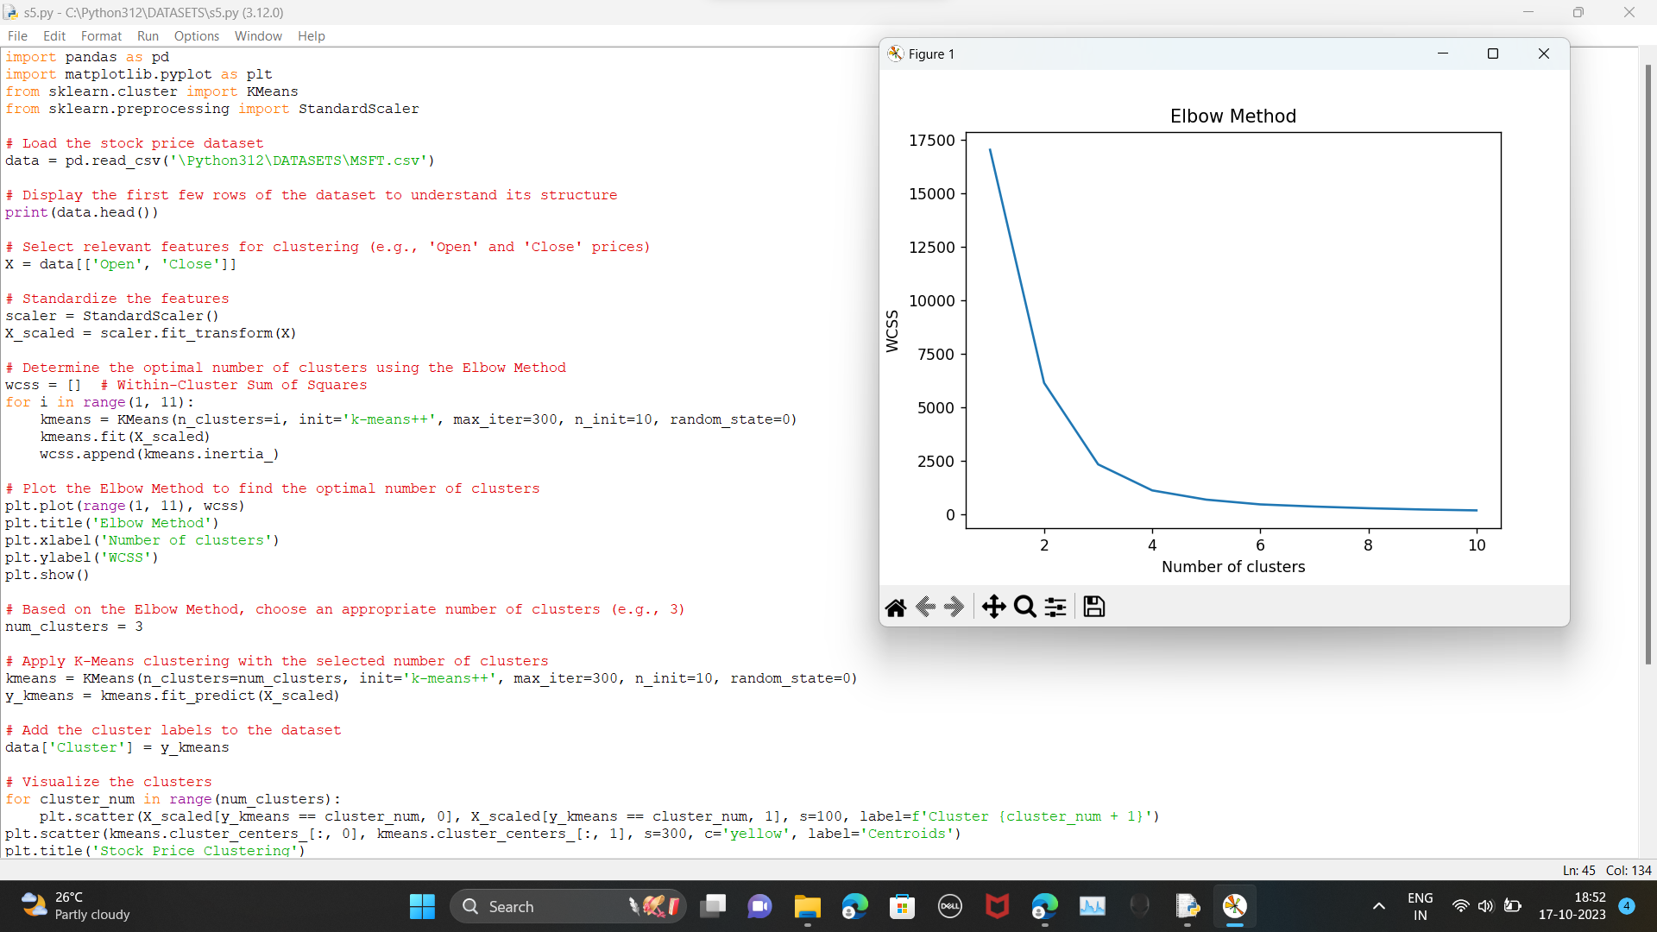

Data visualization code :

# Import necessary libraries

import numpy as np

import pandas as pd

import matplotlib.pyplot as plt

import seaborn as sns

from sklearn.model_selection import train_test_split

from sklearn.linear_model import LinearRegression

from sklearn.metrics import mean_squared_error, r2_score

# Load your stock price dataset

# Make sure your dataset is loaded correctly, or provide the correct path to your dataset CSV file

df=pd.read_csv('C:\Python312\DATASETS\MSFT.csv')

# Data preprocessing

# Assuming your dataset contains columns 'Date', 'Open', 'High', 'Low', 'Close', 'Adj Close', 'Volume'

# You might need to parse the 'Date' column into a datetime object

df['Date'] = pd.to_datetime(df['Date'])

# Split the data into features (X) and target (y)

X = df[['Open', 'High', 'Low', 'Volume']]

y = df['Close']

# Split the data into training and testing sets

X_train, X_test, y_train, y_test = train_test_split(X, y, test_size=0.2, random_state=42)

# Create a linear regression model

model = LinearRegression()

# Fit the model to the training data

model.fit(X_train, y_train)

# Make predictions on the test data

y_pred = model.predict(X_test)

# Calculate mean squared error and R-squared

mse = mean_squared_error(y_test, y_pred)

r2 = r2_score(y_test, y_pred)

print(f'Mean Squared Error: {mse:.2f}')

print(f'R-squared: {r2:.2f}')

# Data visualization

# Box plot for the 'Close' price

plt.figure(figsize=(12, 6))

plt.subplot(1, 3, 1)

sns.boxplot(y=df['Close'], color='skyblue')

plt.title('Box Plot of Close Price')

plt.ylabel('Close Price')

# Scatter plot of 'High' vs. 'Low'

plt.subplot(1, 3, 2)

plt.scatter(df['High'], df['Low'], alpha=0.5, c='g')

plt.title('Scatter Plot of High vs. Low')

plt.xlabel('High Price')

plt.ylabel('Low Price')

# Histogram of 'Close' price

plt.subplot(1, 3, 3)

plt.hist(df['Close'], bins=20, color='orange', edgecolor='black')

plt.title('Histogram of Close Price')

plt.xlabel('Close Price')

plt.ylabel('Frequency')

plt.tight_layout()

# Line plot of 'Close' price over time

plt.figure(figsize=(8, 6))

plt.plot(df['Date'], df['Close'], color='blue')

plt.title('Line Plot of Close Price Over Time')

plt.xlabel('Date')

plt.ylabel('Close Price')

plt.xticks(rotation=45)

plt.show()

output :

BOX PLOT ,SCATTER PLOT,HISTOGRAM

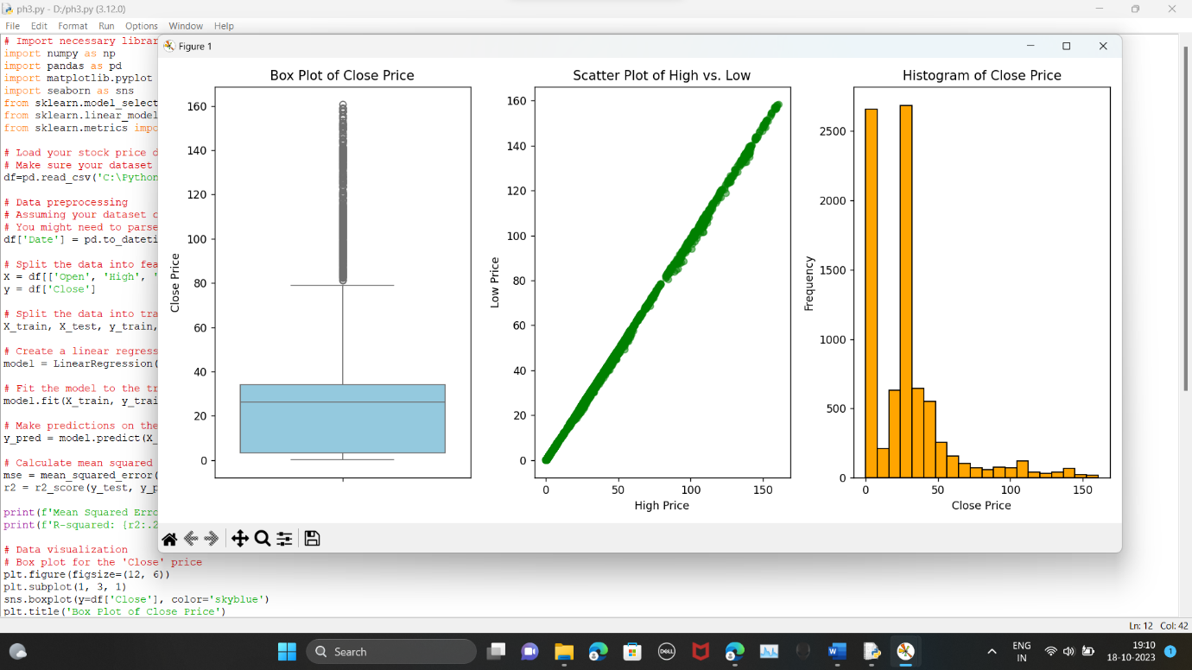

LINE PLOT OF CLOSE PRICE OVER TIME

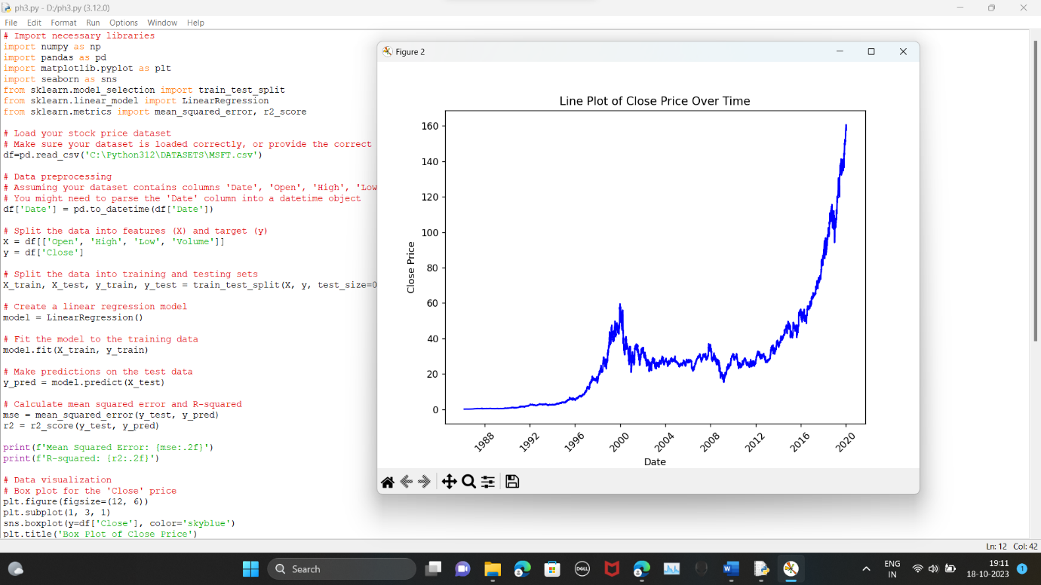

CHECKING THE MISSING VALUES

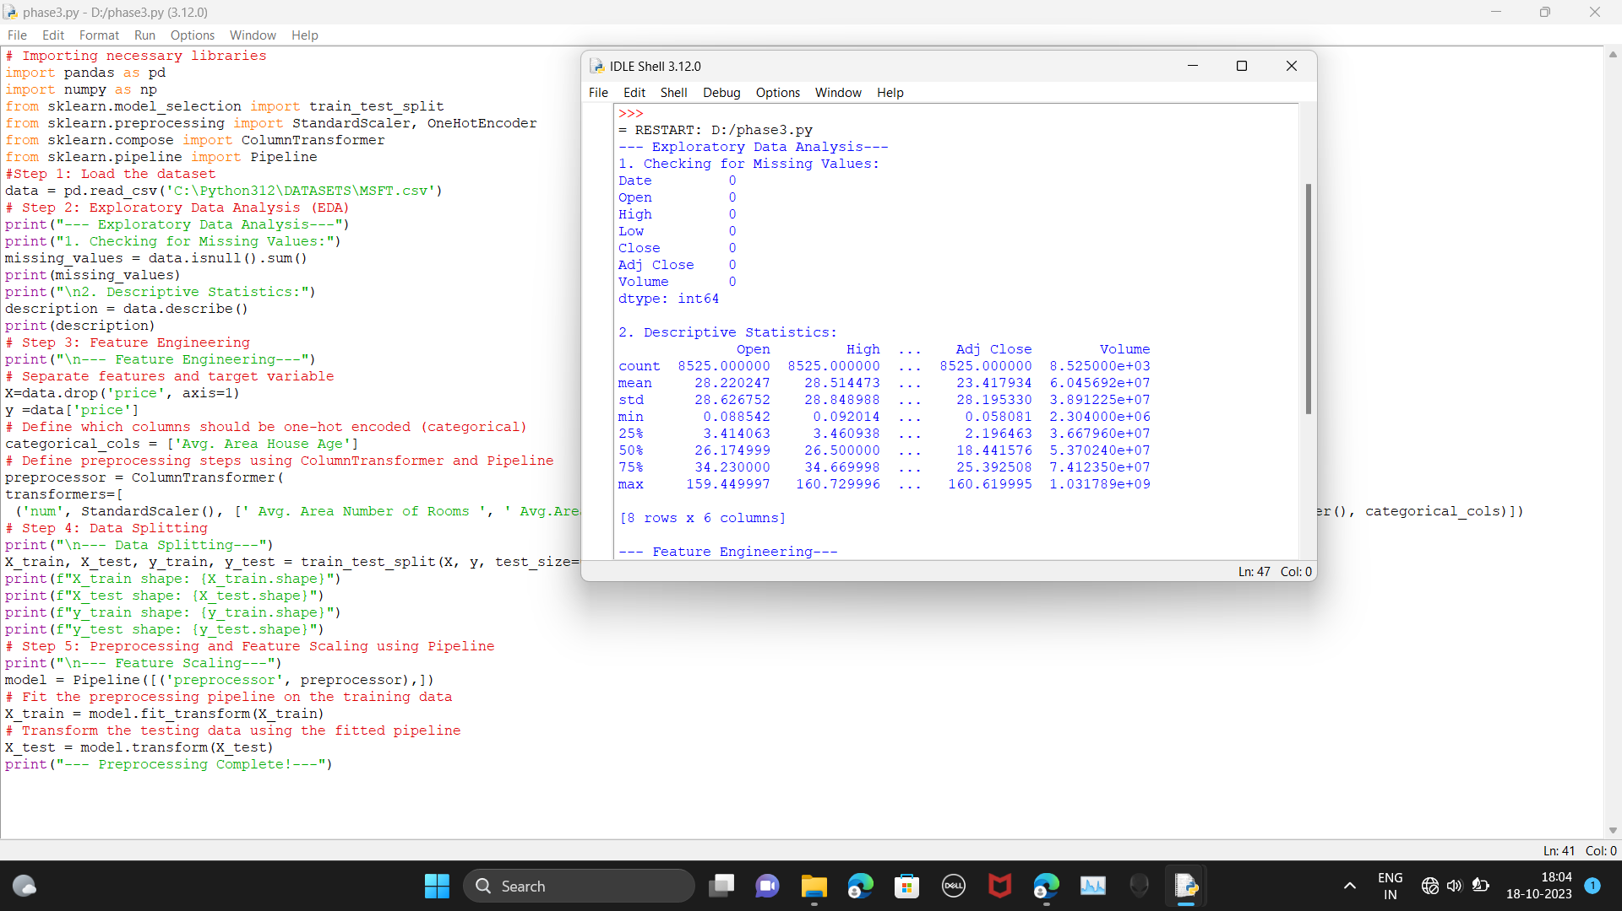

Advantages:

1. Machine Learning Models: Machine learning models, such as linear regression, decision trees, and neural networks, can analyze historical stock data to identify patterns and make predictions based on those patterns.

2. Big Data and Computational Power: With the availability of big data and powerful computing resources, it's possible to process and analyze vast amounts of data quickly, which can lead to more accurate predictions.

3. Feature Engineering: You can use various features like historical price data, trading volume, technical indicators, news sentiment, and economic indicators to improve the accuracy of predictions.

4. Algorithmic Trading: Stock price prediction models can be integrated into algorithmic trading systems, allowing for automated trading strategies that react to market conditions in real-time.

5. Risk Management: Predictive models can assist in risk management by identifying potential trends and outliers in the data, which can be crucial for making informed investment decisions.

6. Continuous Learning: Machine learning models can adapt to changing market conditions by continuous learning, which allows them to remain relevant and make accurate predictions over time.

Disadvantages:

1. Market Complexity: The stock market is influenced by numerous complex factors, including geopolitical events, market sentiment, and unpredictable events. Models may struggle to account for these factors accurately.

2. Data Quality: Stock price data can be noisy and prone to errors, which can lead to inaccurate predictions if not properly cleaned and preprocessed.

3. Overfitting: Models may perform well on historical data but fail to generalize to new data, especially if they are overfitted. Avoiding overfitting is a significant challenge in stock price prediction.

4. Market Volatility: Sudden and extreme market volatility can lead to unexpected price movements that models may not be able to predict accurately.

5. Regulatory Constraints: Stock markets are subject to regulations, and certain trading strategies or predictions may not be allowed or may have legal constraints.

6. Information Lag: By the time news or events are reflected in stock prices, it may be too late to profit from a prediction, as markets are quick to adjust.

7. Ethical Concerns: Predictive models can be misused for market manipulation or unethical practices, and there are concerns about the ethics of high-frequency trading and speculative trading based on predictive algorithms.

BENIFTS OF STOCK PRICE PREDICTION:

1. Informed Investment Decisions: Stock price predictions can provide investors with valuable insights into potential price movements, helping them make informed decisions about buying or selling stocks. This can lead to improved portfolio performance and risk management.

2. Risk Management: Predictive models can assist in identifying potential risks and market trends, enabling investors to adjust their portfolios and investment strategies to mitigate risks and capitalize on opportunities.

3. Algorithmic Trading: Stock price prediction models are widely used in algorithmic trading, where automated systems execute trades based on real-time or predicted market conditions. This can lead to faster and more efficient trading and can take advantage of short-term price discrepancies.

4. Market Timing: Accurate predictions can aid in timing the market, allowing investors to buy or sell assets at optimal points to maximize profits or minimize losses.

5. Diversification: Predictions can help investors diversify their portfolios by identifying undervalued or promising stocks across different sectors and industries.

6. Hedging Strategies: Investors can use stock price predictions to implement hedging strategies to protect their investments from adverse market movements.

7. Research and Analysis: Stock price prediction models can be valuable tools for financial analysts, enabling them to perform in-depth research and analysis to support their investment recommendations.

8. Portfolio Optimization: By using predictions, investors can optimize their portfolios to achieve specific financial goals, such as maximizing returns or minimizing risk.

9. Long-Term Planning: Investors can use predictions to make long-term financial plans, including retirement planning and wealth accumulation strategies.

10. Data-Driven Decision-Making: Predictive models encourage a data-driven approach to investment decisions, reducing reliance on gut feelings and emotions, which can lead to more rational and disciplined trading.

11. Economic Forecasting: Stock price predictions can offer insights into the broader economic landscape, as stock prices are often influenced by macroeconomic factors and market sentiment.

12. Educational Purposes: Stock price prediction can be a valuable tool for educational purposes, helping students and aspiring investors learn about financial markets and the complexities of stock price movements.

CONCLUSION:

Predicting stock prices using machine learning represents a transformative and promising approach that has the potential to revolutionize the financial industry. Throughout this exploration, we have unveiled the remarkable capabilities of machine learning in providing more accurate, data-driven, and nuanced predictions for stock values. As we conclude, several key takeaways and implications emerge:

Improved Accuracy: Machine learning models take into account a plethora of variables, many of which may be overlooked by traditional methods. This results in more accurate predictions, benefiting both investors and traders who can make informed decisions based on a stock's true value.

Data-Driven Insights: These models provide valuable insights into the stock market by identifying trends, market conditions, and other factors that influence stock prices. This information can be invaluable for investors, financial analysts, and policymakers seeking to make strategic decisions.

Market Efficiency: The increased accuracy in pricing predictions can lead to a more efficient stock market, reducing overvaluation and undervaluation of stocks. This contributes to a fairer and more transparent marketplace.

Challenges and Considerations: Machine learning for stock price prediction is not without its challenges. Data quality, model interpretability, and ethical concerns are important considerations. Addressing these issues is crucial for the responsible and ethical deployment of this technology.

Continual Advancement: The field of machine learning is continually evolving, and as it does, so will the accuracy and capabilities of predictive models. As more data becomes available and algorithms improve, we can expect even more sophisticated predictions in the future.

In conclusion, the application of machine learning in predicting stock prices is a groundbreaking development with far-reaching implications. It empowers individuals, businesses, and governments to navigate the financial markets with more confidence and precision. However, it is essential to approach this technology with a clear understanding of its potential and limitations, ensuring that its benefits are harnessed responsibly for the betterment of the financial industry and society as a whole. As machine learning continues to advance, we can look forward to a future where stock price prediction becomes increasingly precise and data-informed.